Lichfield City Council
Donegal House, Bore Street, Lichfield, WS13 6LU

For more information, contact:
Sarah Wallace: telephone 01543 309854
email: sarah.wallace@lichfield.gov.uk
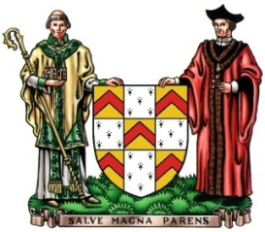
The Sheriff’s Ride - 9 September 2017
The Sheriff of Lichfield invites competent riders and obedient horses to take part in the 2017 Sheriff’s Ride.
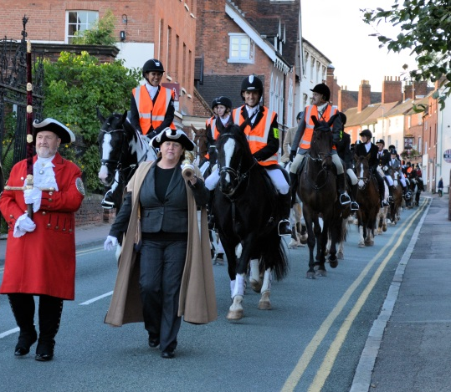
The Ride dates from Queen Mary’s Charter of 1553 in which Lichfield was separated from Staffordshire and made a ‘City and County’ with a right to appoint its own Sheriff.
The charter commanded the Sheriff to make a ‘complete perambulation’ of the City boundary each year on 8 September - the Feast of the Nativity of the Blessed Virgin Mary. This event became known as the Sheriff’s Ride and has been held each year, without interruption ever since.

The Ride
The Ride assembles at Lichfield College Campus and then follows a clearly marked route of about 20 miles around the boundary of the City, including bridleways, cross-country and some road sections. At all times the Ride is accompanied by Police and by mounted Marshals. Support vehicles following the Ride include; paramedics, a vet and an equine ambulance. A farrier is available at the lunch and teatime stops.

There will be a short stop mid-morning and another short stop mid-afternoon where refreshments and toilet facilities are available.
The lunch break will be at Freeford Manor Estate, where there are grassed areas for horses and vehicles. All riders, together with friends and family, are welcome to join the Sheriff in the marquee for lunch, which must be booked/paid for in advance (please contact Sarah Wallace for more information). Alternatively there will be a catering outlet on site where lunches can be purchased on the day; more details and prices will be included in the joining instructions. You are also welcome to bring your own lunch, but as the venue is private grazing pasture please do not bring glass onto the site, and please dispose of litter responsibly.
There will be a rubbish collection point near the marquee.
There will be an award for best presented horse and rider. Judging for this takes place at 9.30am at the Ride Assembly.
Please note that riders taking part do so at their own risk and must abide by the Ride Rules. The Ride is only open to competent & experienced riders of 16 years or over.

APPLYING TO TAKE PART IN THE RIDE

Please complete and return the registration form, together with a non-refundable registration fee of £30 no later than 5.00pm on FRIDAY 1 SEPTEMBER.
Please note that Riders will not be permitted to register after this date.

Joining instructions will be issued prior to the Ride. Riders must sign-in on the day of the Ride and be tacked and ready by 10.00am at the latest as the Ride will commence at 10.30am prompt.
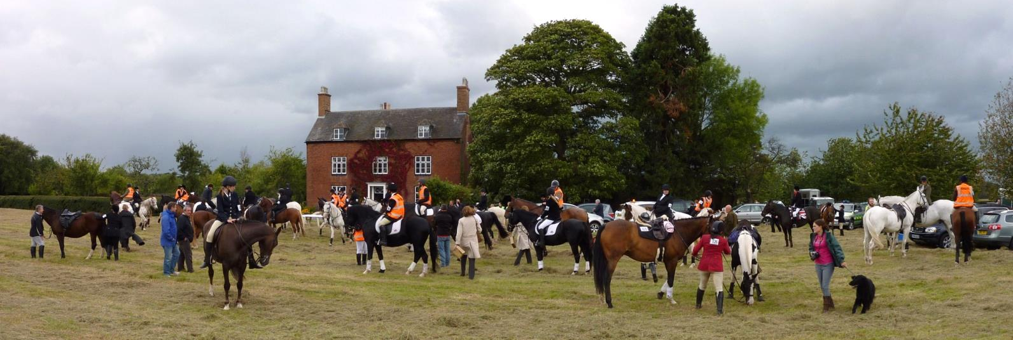
Afternoon Stop

RIDE RULES
- All riders/owners take part at their own risk, and each rider is responsible for himself/herself and their horse.
- All riders must abide by the Rules.
- Only riders, who have had their applications accepted, and paid their registration fee, may take part in the Ride. Ride entries are not transferrable to another rider, and entries on the day will not be accepted
- Riders must be aged 16 years or over on the date of the Ride.
- Riders must wear protective headgear to current standards and riding boots. Body protectors may be worn but are not a requirement. To ensure a high standard of appearance hunting or show dress is required. There will be an award for best presented horse and rider.
- Riders must obey the instructions of the appointed Ride Marshals. The Chief Marshal and Clerk of the Course decisions are final.
- It is the responsibility of each rider to ensure that their horse is safe in the company of other horses and on the public highway. Riders should be competent and able to control the horse which they are riding.
- Any Rider or horse considered by the Marshals to be a danger to other riders will be instructed to leave the Ride.
- Long dressage or schooling whips are not permitted.
- Riders must stay in their allocated riding blocks and must not ride in front of the lead riders or Marshals leading each block.
- Riders must wear their official Ride Number at all times; this is for identification purposes only and will be posted out with the joining instructions.
- Riders retiring from the Ride, or instructed to leave the Ride, will need to make their own arrangements for themselves and their horse to be collected. Riders must therefore make arrangements to comply with this requirement at all times while the Ride is taking place.
ADDITIONAL NOTES:
Please note that this traditional event will take place regardless of the weather; but in the interests of safety during adverse conditions the organisers may change the published route.
Participants should therefore be prepared for wet weather conditions.

SHERIFF’S RIDE - 9 SEPTEMBER 2017
REGISTRATION FORM
[please print clearly and complete all sections]
Name
Address
(including postcode)
Telephone
Email
Please advise of any medical conditions which you feel are relevant.
IN THE EVENT OF AN EMERGENCY
[supply a name and number at which they will be contactable on the day]
Name of Contact
Their phone number
FOR RIDERS UNDER 18 YEARS A PARENT OR GUARDIAN MUST
COMPLETE THIS SECTION [Under 16’s are not permitted to ride]
I give permission for the above named to participate in the ride.

Signed:
Telephone contact
(if different from emergency contact)
I HAVE READ AND AGREE TO ABIDE BY THE RIDE RULES [the rider must sign]
Signed:
I enclose a non-refundable registration fee of £30.
Cheques payable to ‘Lichfield City Council’
If you wish to pay by BACS please contact: Sarah Wallace on 01543 309854 or
Email sarah.wallace@lichfield.gov.uk for account details and reference.
Please return to: Sarah Wallace, Lichfield City Council,
Donegal House, Bore Street, Lichfield, WS13 6LU [by Friday 1 September]

