Lichfield City Council  City Council Offices, Donegal House, Bore Street, Lichfield, WS13 6LU  Town Clerk: Anthony Briggs B.A. (Hons), CilCA | 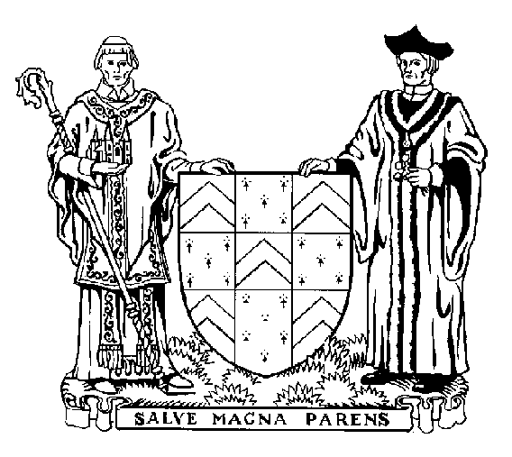

PRIVATE AND CONFIDENTIAL
APPLICATION FOR THE POST OF: Museums and Heritage Officer
FIRST NAMES: |  |  | ADDRESS
SURNAME:
PREFERRED TITLE (e.g. Mr, Mrs, Miss, Ms, Dr)
Home Tel:
Work Tel: |  |  | POSTCODE
Mobile: |  |  | Do you have access to a car? |  | YES / NO
Email: |  |  | Do you have a current driving licence? |  | YES / NO
EDUCATION (Give Dates)
Last School Attended |  | From | To | Examinations passed (with grades)
College/University |  | From | To | Examinations passed (with grades)
Further Education and Training |  | From | To | Examinations passed (with grades)
Professional Membership and Qualifications:

 | PRESENT APPOINTMENT: |  |  |  |  | When appointed:
 | Name and address of present employer |  |  |  |  | Present pay / salary (per annum)
PREVIOUS EMPLOYMENT HISTORY - starting with the most recent:
Employer |  |  | From | To | Position held

Please give details of RELEVANT EXPERIENCE or qualifications which are especially appropriate to the job you are applying for, and explain why you believe you would be suitable for this post. (Continue on a separate sheet if necessary)

Please give details of any other particulars to which you wish to draw our attention
INTERESTS Please give details of pastimes, hobbies, sports etc.
REFERENCES
Please provide names, address, and (if possible) email address and telephone numbers of two persons we could approach for references. One should be your present employer, unless there are special reasons against this.
1 |  |  | 2
Can we contact this referee BEFORE interview? |  | YES / NO | Can we contact this referee BEFORE interview? |  | YES / NO
Please note that if references have not been obtained prior to interview, references will need to be taken up before any firm offer of appointment can be made
Period of Notice required to terminate present employment:
NATIONAL INSURANCE NUMBER:
DO YOU CONSIDER YOU HAVE ANY PHYSICAL DISABILITIES? (If yes, please give details below) |  |  |  |  | YES / NO
ARE YOU REGISTERED DISABLED? |  |  | YES / NO
(If ‘Yes’, please give Registration Number):

CRIMINAL CONVICTIONS
Under the provisions of the Rehabilitation of Offenders Act, 1974 you are required to give details of any convictions which are not spent. Failure to do so may render you liable to summary dismissal.
Do you have any current convictions against you? (If yes, please give details below) |  |  |  | YES / NO
WORK WITH YOUNG PEOPLE UNDER 18 YEARS, ELDERLY, SICK OR DISABLED
Under the provisions of the Rehabilitation of Offenders Act, 1974 (Exceptions) (Amendment) Order, 1986 you are required in certain circumstances to give details of any criminal conviction, including those which are spent. Failure to do so may render you liable to summary dismissal.
Because of the nature of this post you are REQUIRED / NOT REQUIRED to answer the following question:
Do you have any spent convictions? (If YES, please give details below)
NOT REQUIRED
Are you related to any member or employee of the City Council? (If YES, please give details below) |  |  |  | YES / NO
Please state where you saw the advertisement for this post:
I declare that all the information I have provided is true, that I have not canvassed a member/officer of the Council in connection with this application and that I will not do so. I understand that such canvassing will disqualify me as a candidate. I also understand that failure to disclose any relationship with a member/officer or providing untrue information will disqualify me and that if such failure/untrue information is discovered after appointment, I may be liable to dismissal without notice.
Signed: |  | Date:

When completed this form should be returned in an envelope marked
"PRIVATE AND CONFIDENTIAL - APPLICATION"
and sent to:
Tony Briggs, Town Clerk, Lichfield City Council, Donegal House, Bore Street, Lichfield, WS13 6LU

Alternatively, you may email your completed application form to vacancies@lichfield.gov.uk in which case, if you are called for interview, you will be required to sign a hard copy of your application form prior to interview.

Applications submitted by post will not be acknowledged unless you supply an SAE.
If you have not been notified that you have been called for interview within four weeks after the closing date you should consider your application has been unsuccessful.

Closing date for applications: 12 noon, Monday 3 July 2023

It is currently anticipated interviews will take place during week commencing 17 July 2023.

